**Institute of Technology Tralee**

**BSc. in Computing with Specialism (Group 4) - Year 1**

**Continuous Assessment #2**

**Date: 5/12/13**

**Time: 2 – 4 p.m.**

**Introduction to Programming**

**Instructions:** Attempt the following question. You should use the JCreator IDE for coding. When you are finished you must print out your code for correction.

**________________________________________________________**

**Q1.**

A valid time value should have the form hh:mm, where hh is a value between 00 and 23 inclusive and mm is a value between 00 and 59 inclusive. So it will contain exactly 5 characters.

You must write a Java program that reads in a total of 5 user-supplied **strings**, using a **do-while loop**, and tests each one individually to see whether or not it is a valid time value. If it is not, then your program should issue an appropriate message indicating why it failed the test.

Once the 5 values have been entered, the program should display the percentage of values supplied that were valid times.

Using the test values as indicated in the screen shots below, the program should give you **exactly** the following output when it runs, including any banners, blank lines, tabs etc.

Also note that there will be a few marks awarded for having a **single-line comment** and **a meaningful multi-line comment at the top of the program**.

**Sample Screen Shots**

**Run 1 – A number of invalid times are entered, the appropriate reason for being invalid is displayed and in the last loop iteration a valid one is entered. When the loop stops the percentage valid is displayed as 20% in this case**

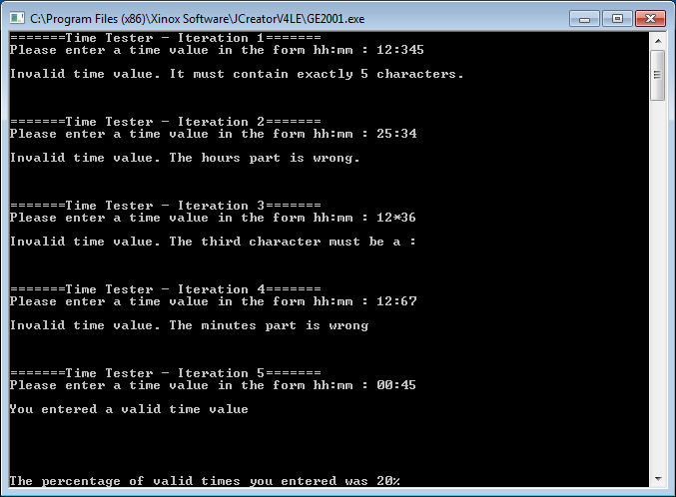

**Run 2 – This time 3 valid times are entered. When the loop stops the percentage valid is displayed as 60% in this case.**

